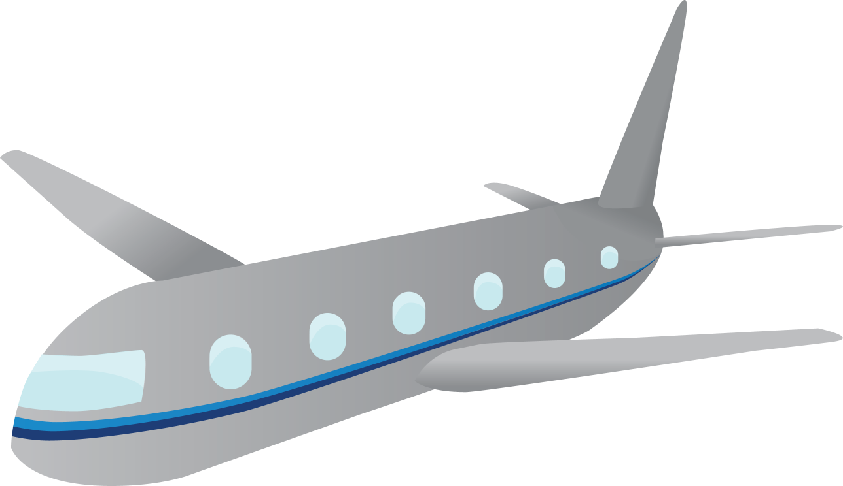

Prepare For Take Off With Tweens
Packing List

CARRY-ON

- Purse/Wallet with ID
- Tissues
- Chapstick
- Hand sanitizer
- Sunglasses/glasses
- Any necessary medications
- Electronics with earbuds and charging cords
- Activity books, reading books, homework
- Travel games or a deck of playing cards
- Camera
- Journal and pen
- Snacks
- Comfort item- plush animal, blanket, pillow, etc.
- One complete outfit for emergency changes

Check-In

- One outfit per day, plus one extra (socks and undergarments included)
- Pajamas
- Shoes
- Jacket/coat
- Swimwear if applicable
- Toothbrush & toothpaste
- Shampoo & conditioner
- Soap & lotion
- Sunscreen
- Make-up
- Hair care
- Deodorant

- Notes:

